Configuración actual de CubeMX: Firmware y periféricos

Las siguientes configuraciones deben seguirse en orden.
No se debe modificar nada que no se diga en este archivo, por lo que si al realizar una configuración de las mencionadas aparecen más opciones, dejar como están por defecto las mismas.

RCC:
- LSE: Crystal/Ceramic Resonator.
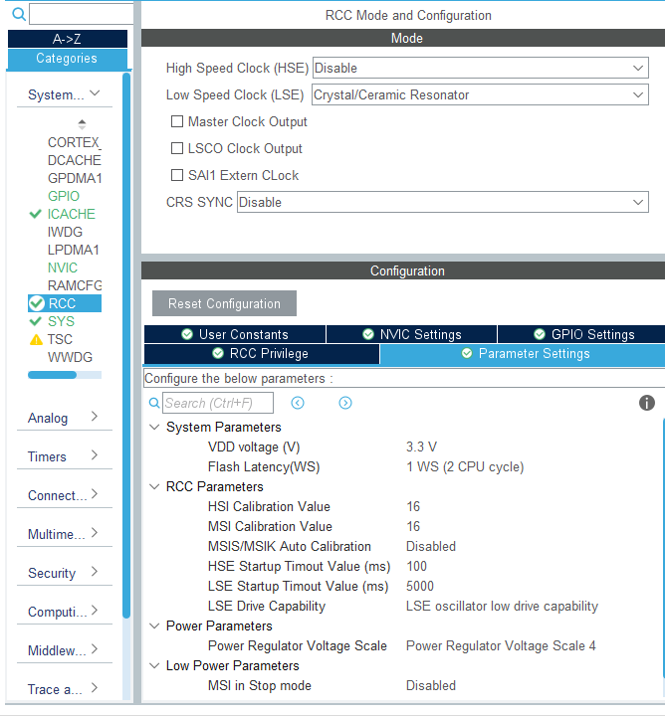
SYS:
- Timebase Src: TIM6
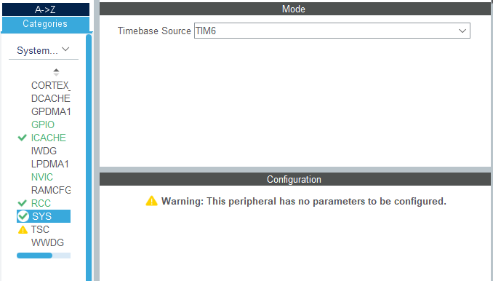

ICACHE:
- Mode: 1-way (direct mapped cache).
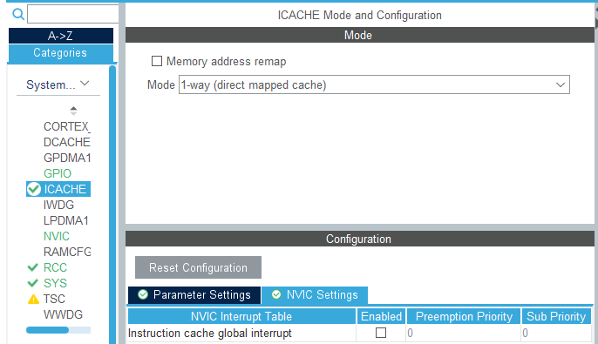

ADC1:
- IN1 IN1 Single-ended.
- IN2 IN2 Single-ended.
- IN3 IN3 Single-ended.
- IN4 IN4 Single-ended.
- Temperature Sensor Channel ON.
- Vrefint Channel ON.
- Clock Prescaler: Asynchronous clock mode divided by 2.
- Resolution: ADC 12-bit resolution
- Scan Conversion Mode -> Disabled
- Continous conversión mode -> Disabled
- Discontinuous Conversion Mode -> Disabled
- Enable Regular Conversions: Enable.
- Rank 1 Channel: Channel Temperature Sensor.
Sampling Time: 391.5 Cycles.
Offset Number: No offset.
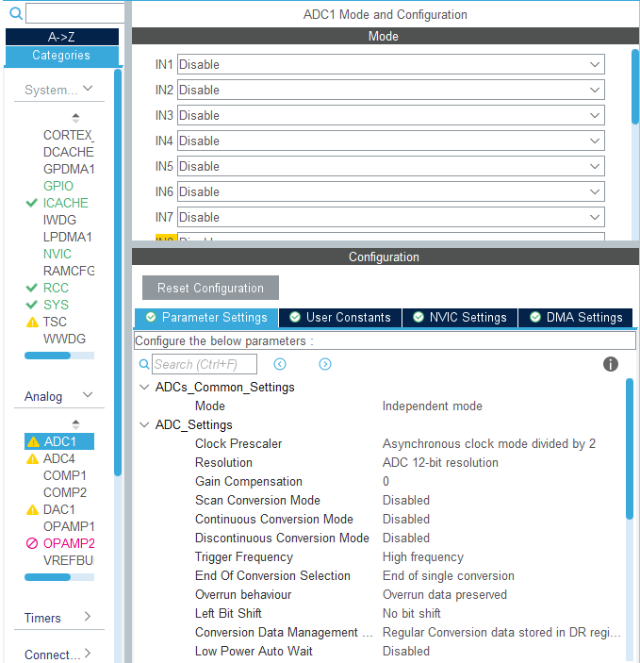

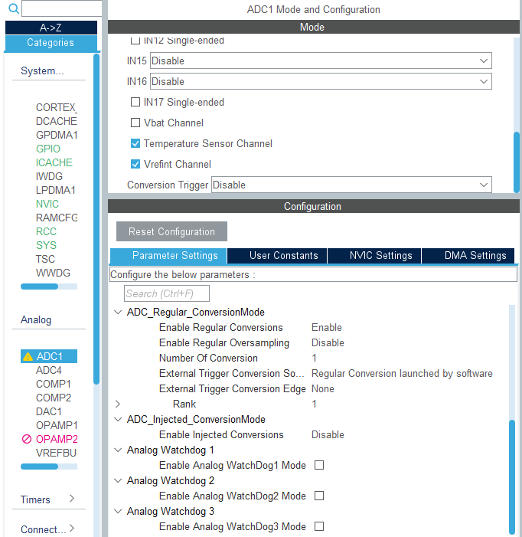

LPTIM1:
- Mode: Counts internal clock events.
- Clock Clock Prescaler: Prescaler Div16.
- Counter Period: 65635.
Repetition counter: 0.
- LPTIM1 global interrupt: Enabled.
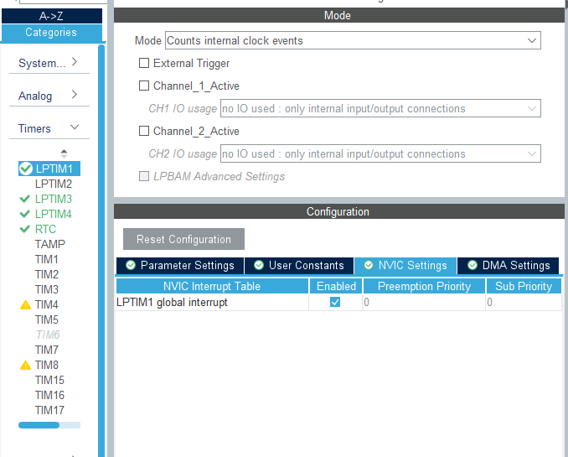

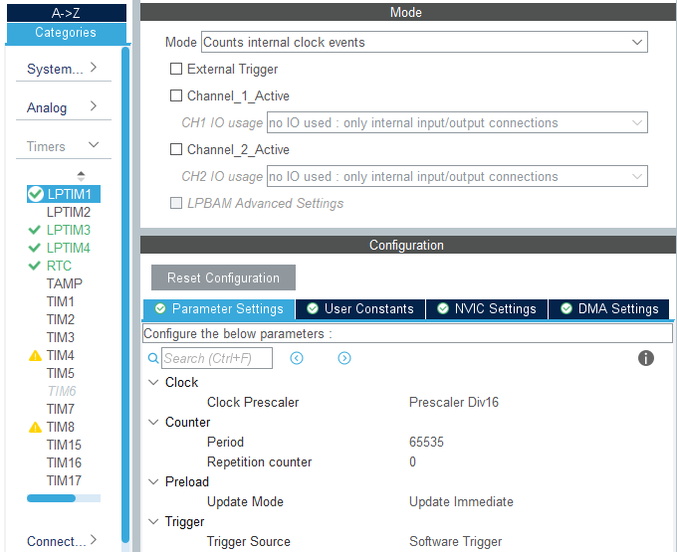

LPTIM3:
- Mode: Counts internal clock events.
- Clock Clock Prescaler: Prescaler Div1.
- Counter Period: 65635.
Repetition counter: 0.
- LPTIM3 global interrupt: Disabled.
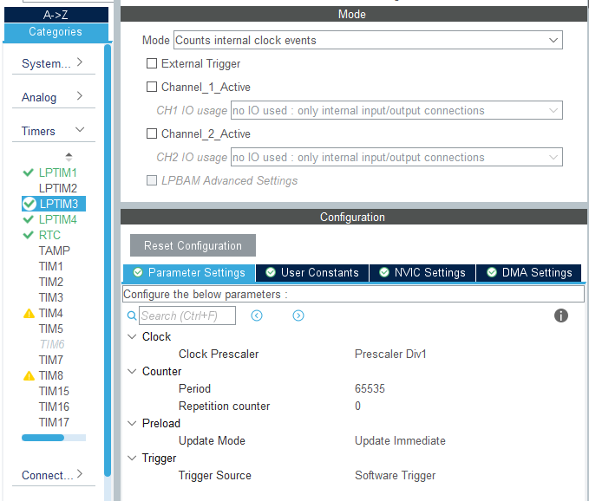

LPTIM4:
- Mode: Counts external Clock events with internal synchronization.
- Clock ULP Clock Polarity: Rising Edge.
- Counter Period: 65635.
Repetition counter: 0.
- LPTIM4 global interrupt: Disabled.

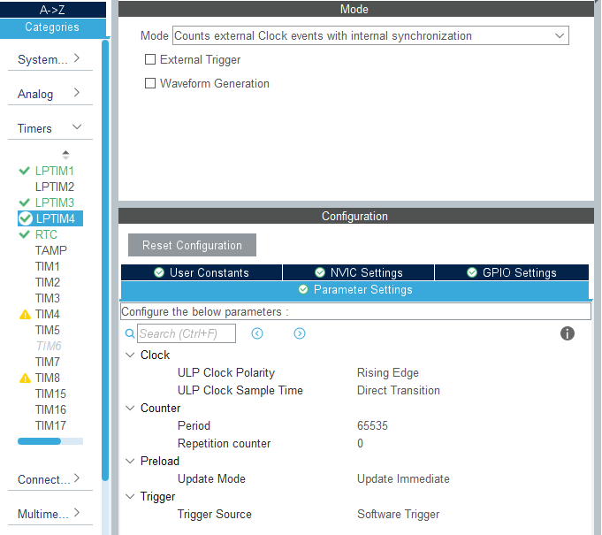

RTC: Descipcion
- Activate Clock Source: ON.
- Activate Calendar: ON.
- WakeUp: Internal WakeUp.
- Hour format: Hourformat 24.
- Data Format: Binary data format.
- Hours: Hora actual.
- Minutes: Minutos actuales.
- Seconds: Segundos actuales.
- Month: Mes actual.
- Date: Día actual (número).
- Year: Año actual.
- Wake Up Clock: RTCCLK/16.
- Wake Up Counter: 4096.
- NVIC Settings RTC non-secure interrupt: Enabled.

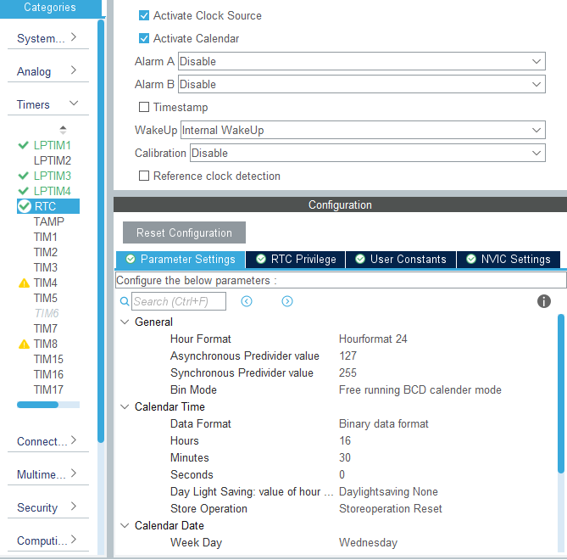
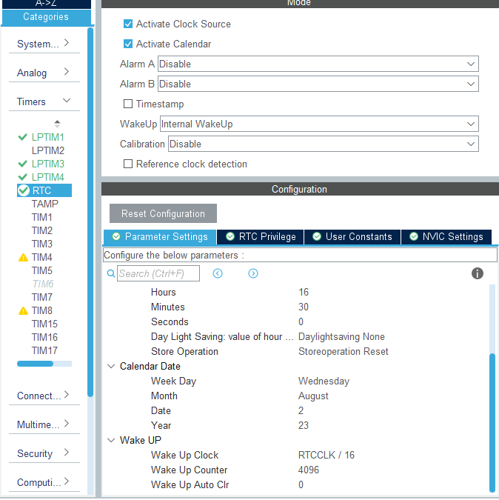

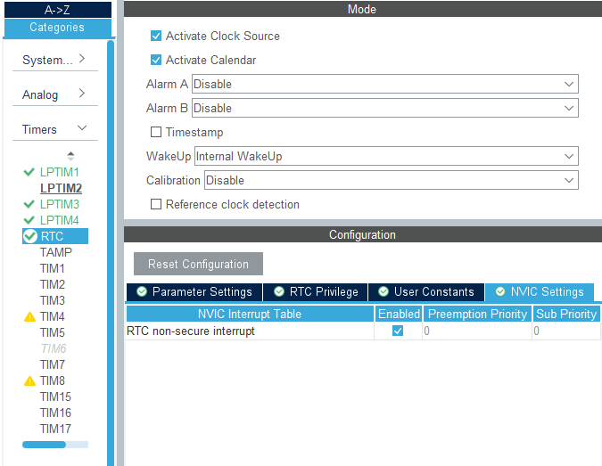

SPI1: Se conecta con el IC driver del LCD PCF8553. El microcontrolador solamente transmite datos. Se busco tasa de transferencia alta, para no estar mucho tiempo fuera de estados de bajo consumo.
- Mode: Half-Duplex Master.
- Data Size: 8 bits.
- Prescaler (for Baud Rate): 16.
- Baud Rate: 1.5 MBits/s.
- CRC Calculation: Disabled.
- NSSP Mode: Disabled.
- NSS Signal Type: Software.
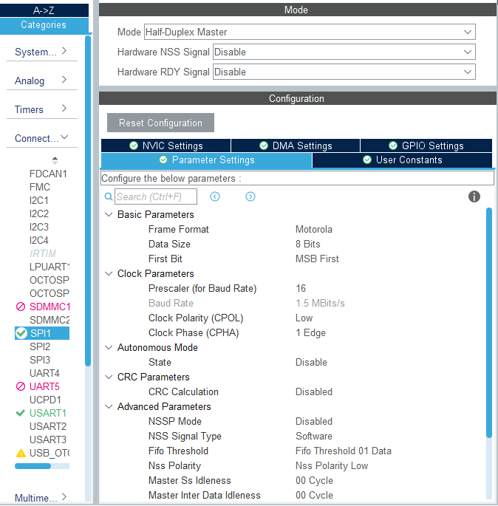

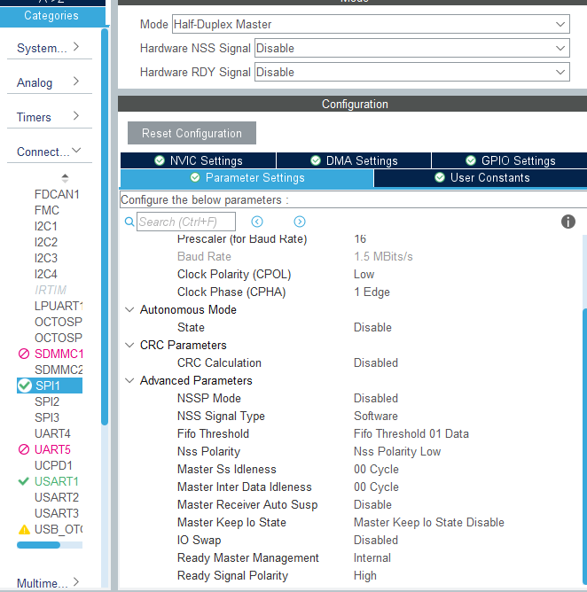

USART1: Se conecta al conector STLINK con propósitos de debuger.
- Mode: Asynchronous.
- Baud Rate: 115200 Bits/s.
- Word Length: 8Bits.
- Data Direction: Receive and Transmit.
USART2: sin implementar, pero se reserva los pines y se lo cablea a placa de usuario.
USART3: Se lo usa para conectar modulo IOT.
- Mode: Asynchronous.
- Baud Rate: 115200 Bits/s.
- Word Length: 8Bits.

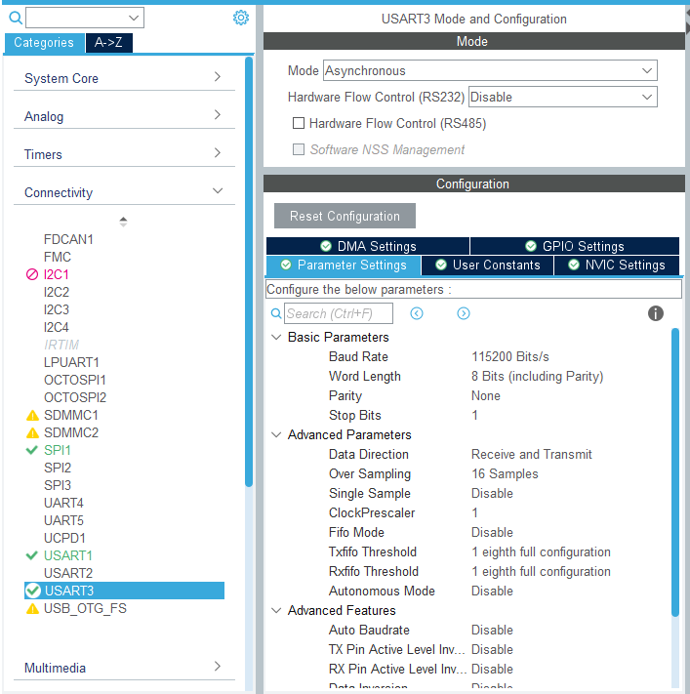

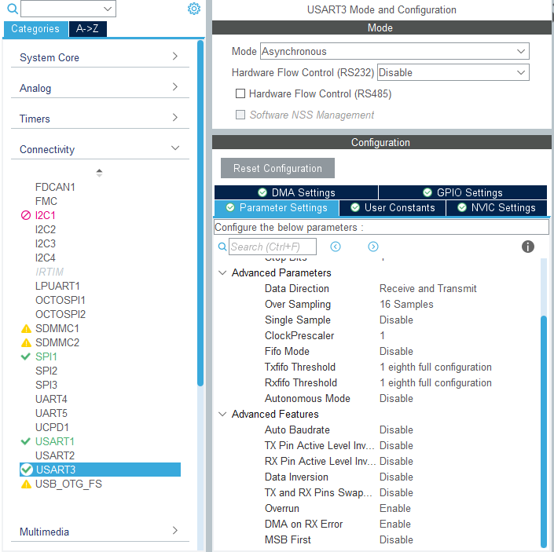

PWR:
- Low Power Dead Battery Signals disabled: ON.
Power saving mode: ON.
- System power supply Power Regulator: SMPS.
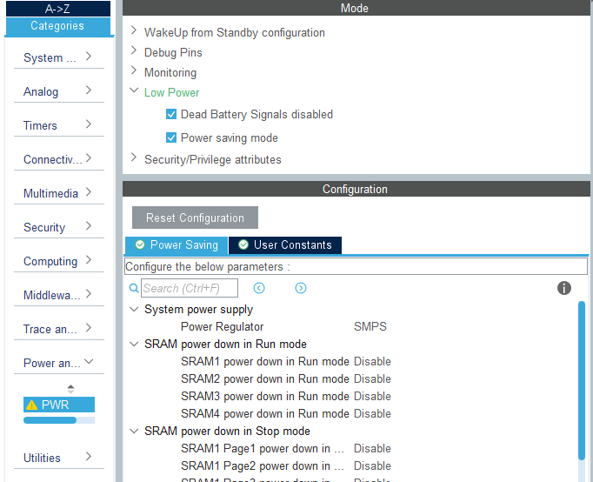

Middleware and Software Packs THREADX:
- Core: ON.
- TraceX Support: ON.
- Low Power support: ON.
- Low Power Enable LowPower Support: Enabled.
TX_LOW_POWER_TIMER_SETUP: app_threadx_lowpower_timer_setup.
TX_LOW_POWER_TICKLESS: Disabled.
TX_LOW_POWER_USER_ENTER: app_threadx_lowpower_enter.
TX_LOW_POWER_USER_EXIT: app_threadx_lowpower_exit.
TX_LOW_POWER_USER_TIMER_ADJUST: app_threadx_lowpower_timer_adjust.
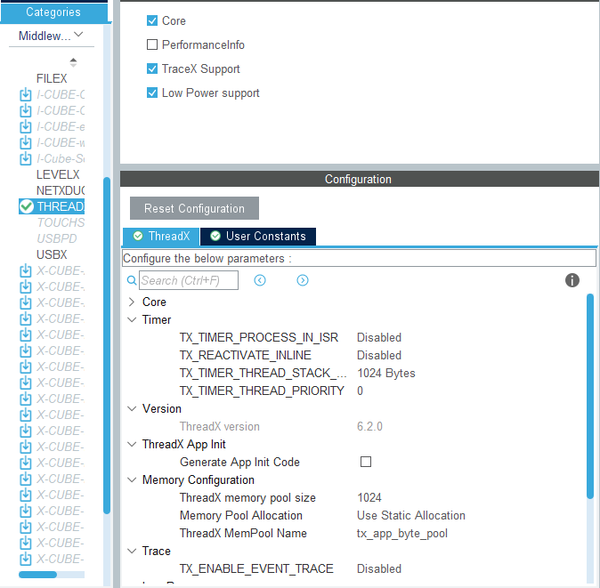

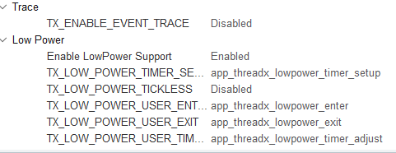

Clock Configuration:
- System Clock Mux MSIS SYSCLK: 24 MHz AHB Prescaler: /1.
- ADC,DAC Clock Mux SYSCLCK: 24 MHz.
- SPI1 Clock Mux SYSCLCK: 24 MHz.
- USART1 Clock Mux SYSCLK: 24MHz.
- RTC Clock Mux LSE: 32.768 KHz.
- LPTIM3,4 Clock Mux LSE: 0.032768 MHz.
- LPTIM1 Clock Mux LSE: 0.032768 MHz.
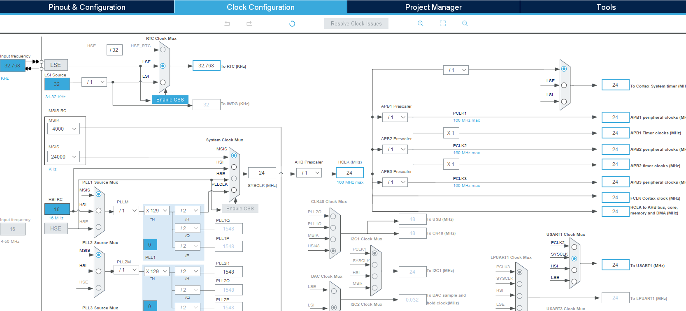
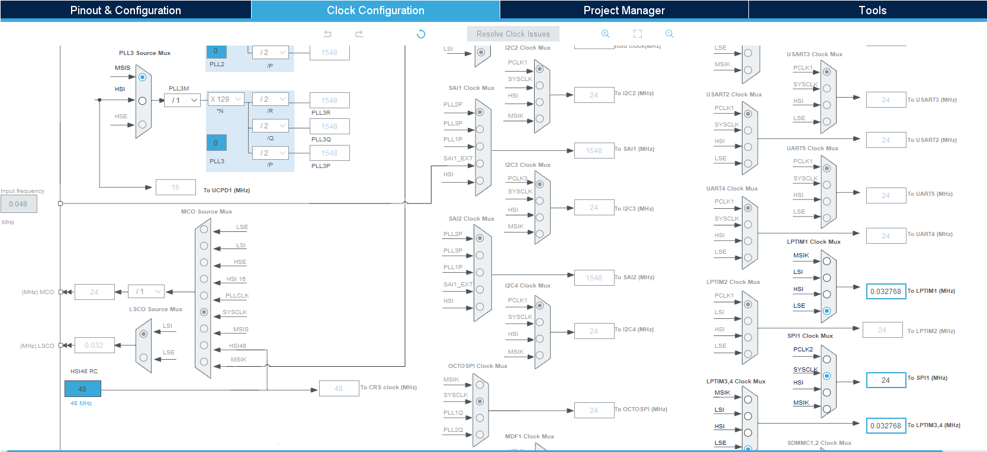
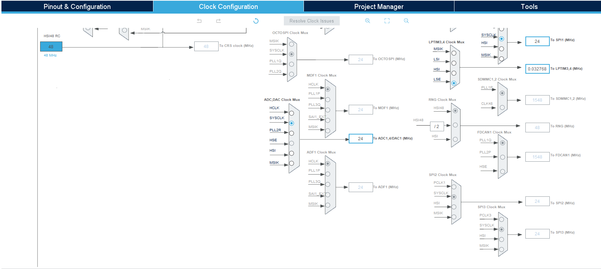

Pinout view:
Pines del micro no conectados sin configuración.
Pines conectador a un port undefined configurarlos como GPIO_Analog y label genérico, es decir nombre del puerto.
- PA1: SPI1_SCK PCF8553_SCL
- PA4: GPIO_OUTPUT PCF8553_CE
- PA6: GPIO_OUTPUT PCF8553_RESET
- PA7: SPI1_MOSI PCF8553_SDIO
- PA9: USART1_TX
- PA10: USART1_RX
- PA13: DEBUG_JTMS-SWDIO
- PA14: DEBUG_JTCK-SWCLK
- PB3: DEBUG_JTDO-SWO
- PB5: GPIO_OUTPUT LED_ERROR_HANDLER
- PB6: GPIO_OUTPUT LED_MCU_RUN
- PB7: GPIO_OUTPUT LED_3
- PC0: ADC1_IN1 RTD_IN
- PC1: ADC1_IN2 BATTERY_LEVEL
- PC2: ADC1_IN3
- PC3: ADC1_IN4
- PC14: RCC_OSC32_IN
- PC15: RCC_OSC32_OUT
- PD8: USART3_TX
- PD9: USART3_RX
- PD13: LPTIM4_IN1 PULSE_IN
- PD14: GPIO_EXTI14 PULSE_IT
- PE10: GPIO_EXTI10 KEY_DOWN
- PE11: GPIO_EXTI11 KEY_UP
- PE12: GPIO_EXTI12 KEY_ENTER
- PE13: GPIO_EXTI13 KEY_ESC

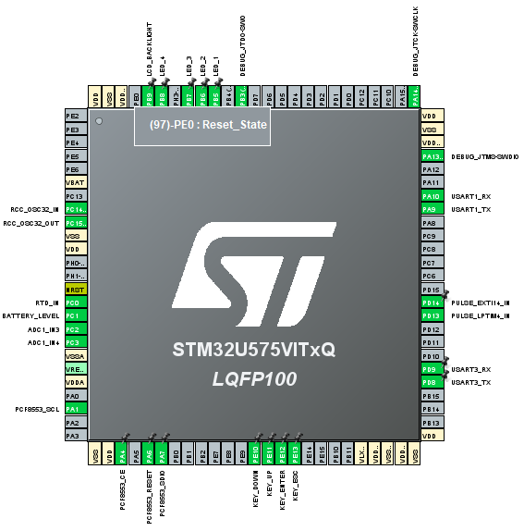

NVIC:
- EXTI Line10: Enabled Preemption Priority: 5.
- EXTI Line11: Enabled Preemption Priority: 5.
- EXTI Line12: Enabled Preemption Priority: 5.
- EXTI Line13: Enabled Preemption Priority: 5.
- EXTI Line14: Enabled Preemption Priority: 5.
- LPTIM1 global interrupt: Enabled Preemption Priority: 0.
- RTC non-secure interrupt: Enabled Preemption Priority: 0.

